**Report on session 1**

ExhaustiveAnalysis for Indian Agriculture dataset using **Power BI**.

Power BI – Power Business Intelligence

It is used to analyse the data.

It involves ETL process ,where it stands for Extract ,Transform and Load.

Extract: It helps to pull the data from different formats e.g. csv ,excel,

Text etc.

Transform: It helps to remove unnecessary data.

Load: It helps for analysis(Keep facts or Insights via Dash board).

Steps to open power BI:

1.Install app

2. open app

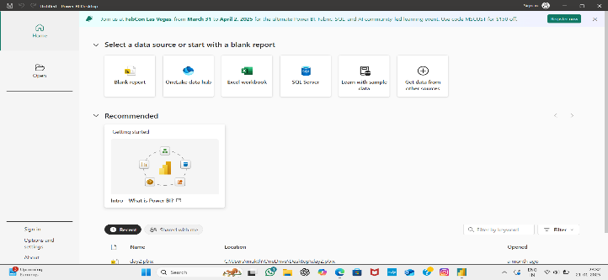 After opening we can see the interface as below

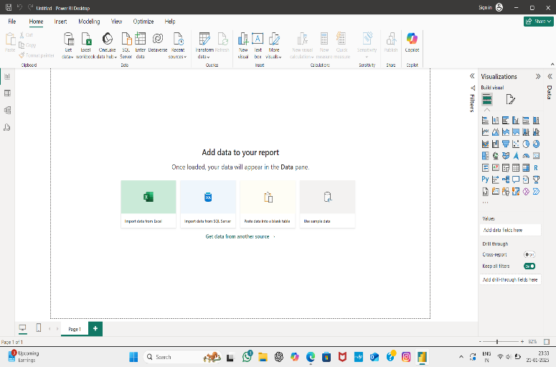We have to select blank report after that we can see the interface as below. We can observe visualization with several charts.

We can load the data to the app by clicking get data.

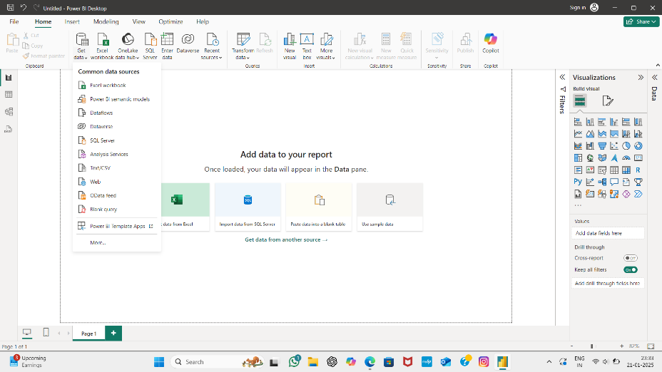

Selecting the file from existing files.

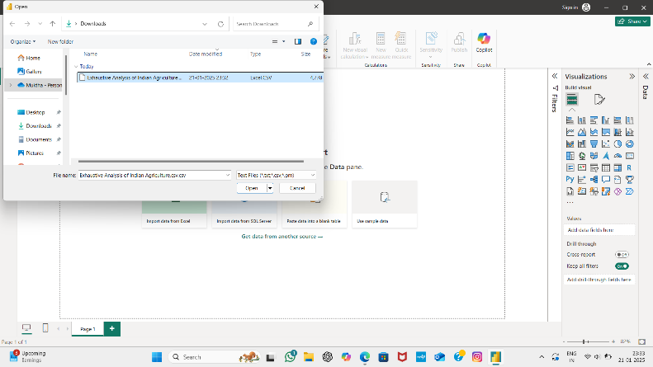

After choosing the file we can choose either Load or Transform

Load: If the data is error free, we can load Directly

Transform: If the data contains unwanted things such as null values,errors.

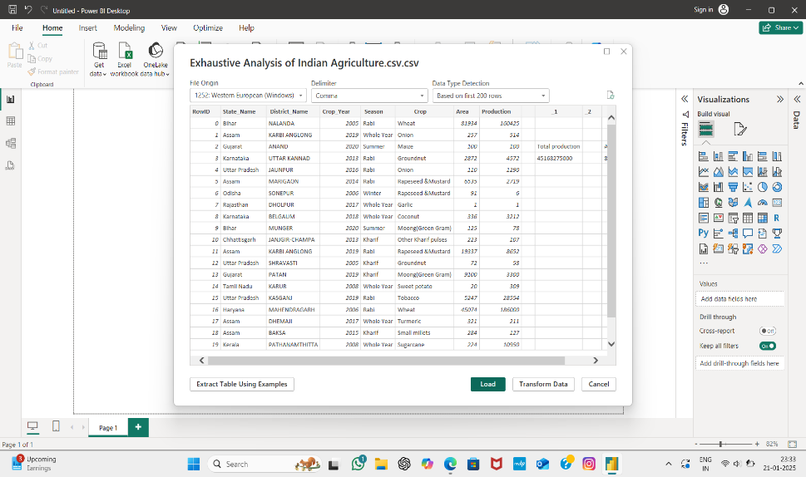

Here we have selected load directly,but we can see the unwanted columns

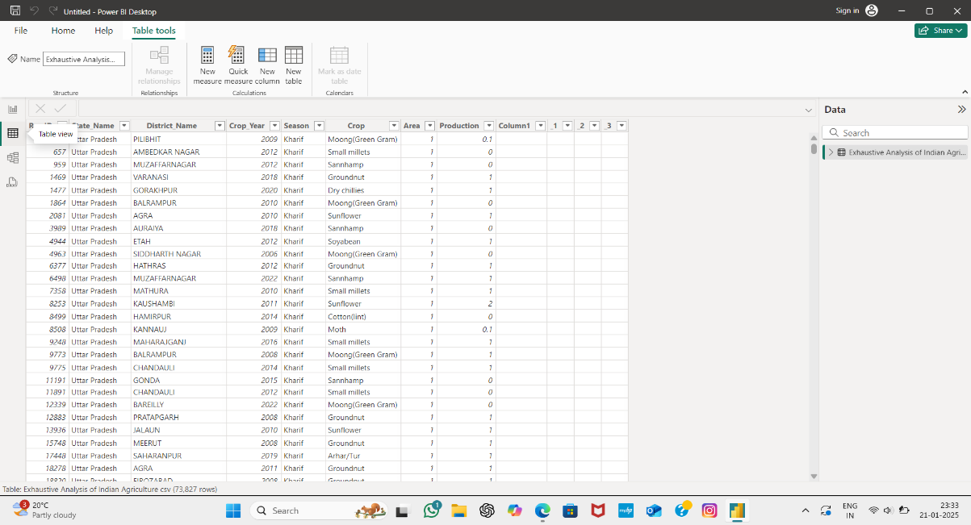

Here we can see the data loaded

**Views**

There are different kinds of Views:

Report view: To perform all visualization tasks.

Table view: The data we are dealing with.

Model view: Creating the relationships between tables.

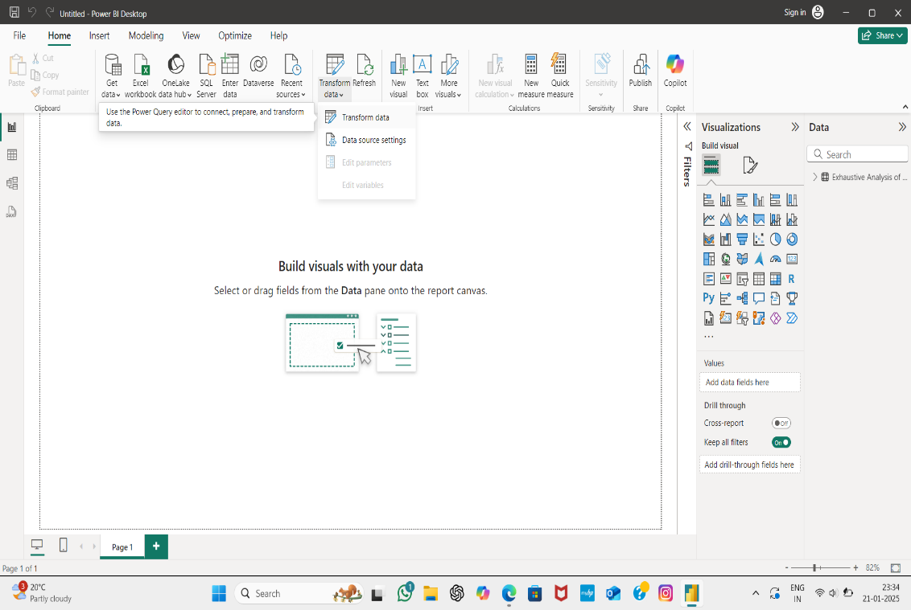 After loading if we find any errors or null values we can choose Transform data option to clean the data.

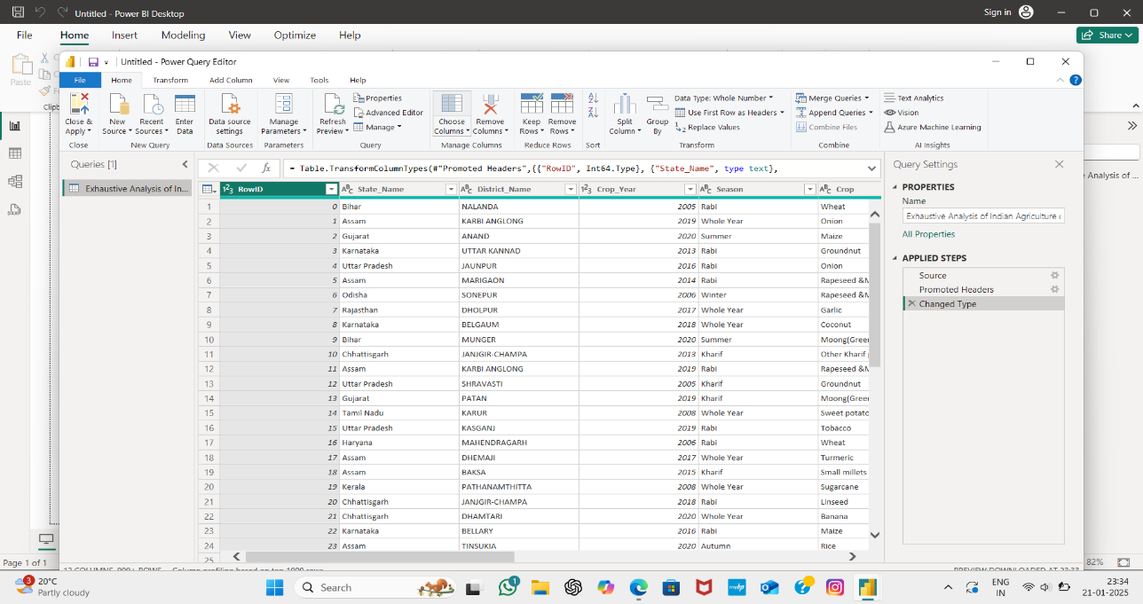If we chose Transform it leads to a window called Power Query Editor. It is a heart of analysis, which helps to clean the data.

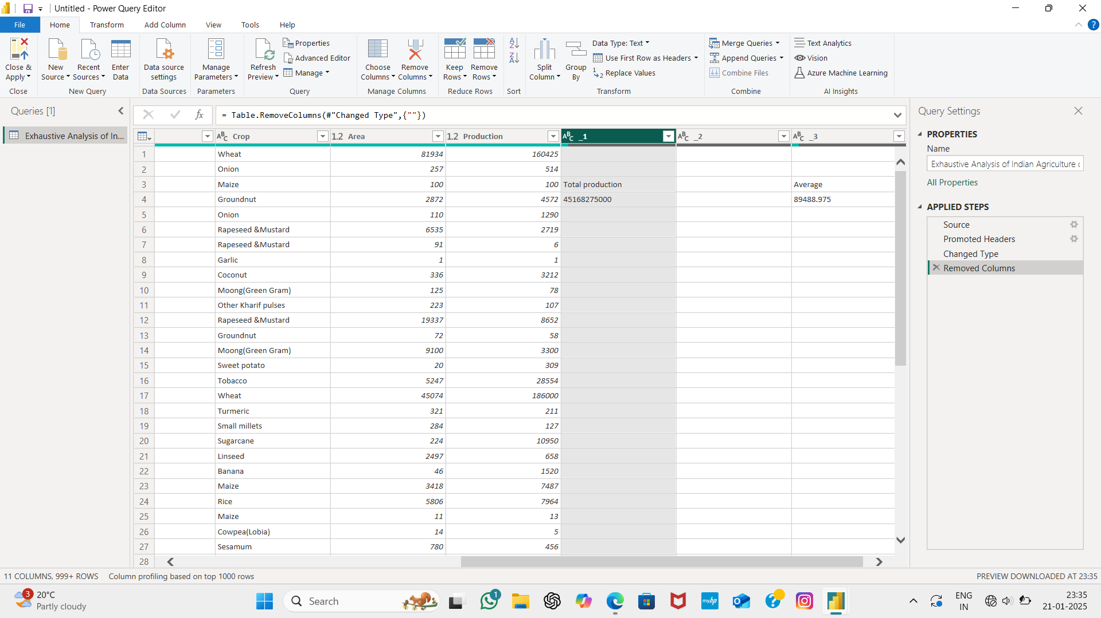In the below picture we can see the empty columns, we can remove it by selecting the column and pressing option remove columns.

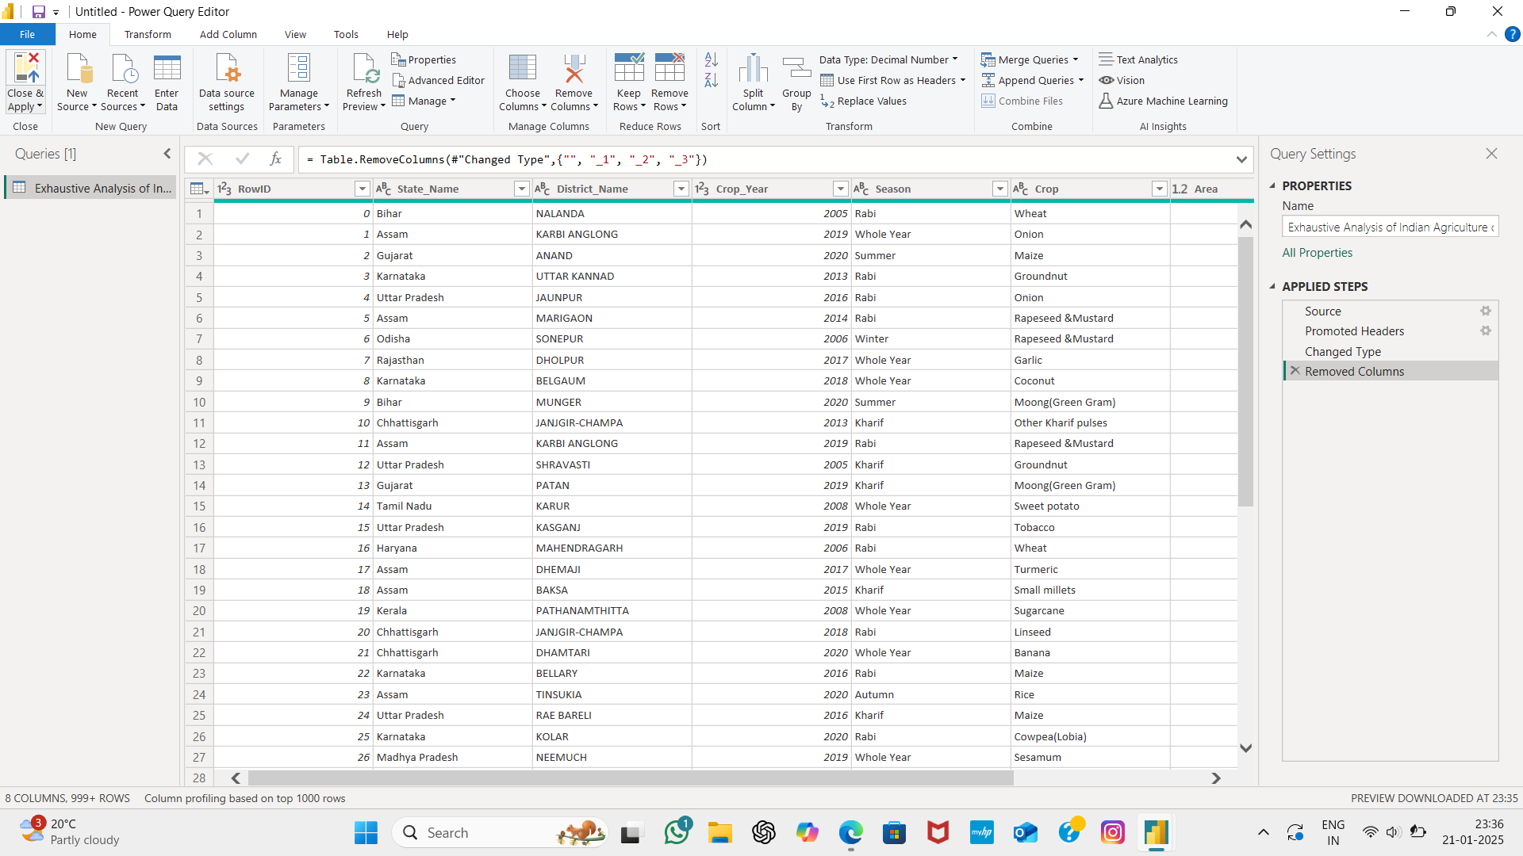We can observe the unwanted columns being removed.

In the right most corner we can see a applied steps, where we can track our actions.

We can also check if there is any errors in the dataset, we can select

View option and select column quality, which shows the quality of each column at the top of the column.

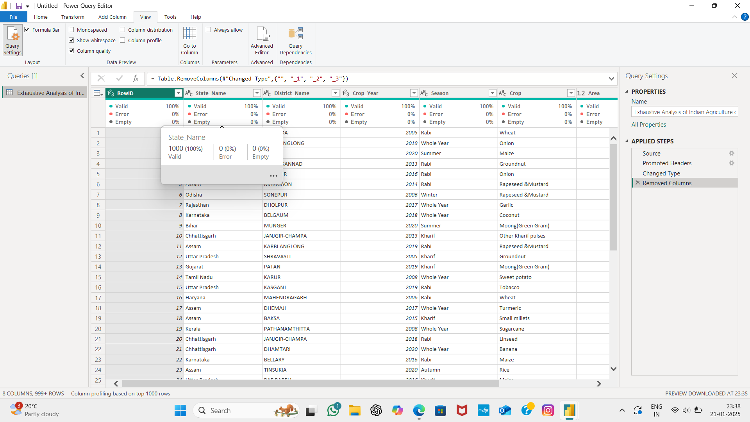

After cleaning a data we should select close and apply to keep changes we made to our data set. It will take out from the power query editor for further visualizations.

